
JULY NEWSLETTER

Special mid-season offers on all High Jump and Pole Vault Equipment!
-
Get massive discounts on Landing Mats, High Jump Stands, Pole Vault Uprights and Wheel Away Covers

Contact us directly for special prices. Only available until the end of August 2015!
  Cantabrian
  Competition High Jump Mat
  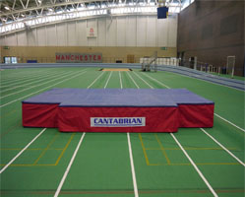
  SPECIAL PRICES AVAILABLE
  Cantabrian Pole Vault Mat
  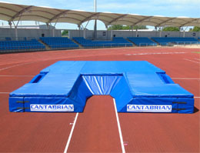
  SPECIAL PRICES AVAILABLE​

  Olympic High Jump Stands
  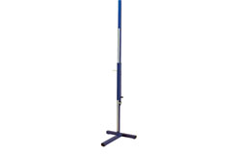
  SPECIAL PRICES AVAILABLE
  High Jump Wheel Away Covers
  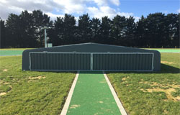
  SPECIAL PRICES AVAILABLE


Athletics Direct was the chosen supplier to provide all of the equipment for the new athletics track built at York Sports Centre. This included the full range of throwing implements, hurdles, high jump equipment and much more.
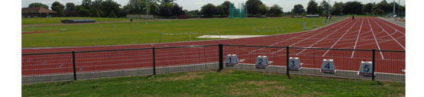
Last month we supplied over 30 x Cantabrian Hurdles as well as an International Cantabrian Pole Vault Bed, Uprights and Wheel Away Cover to the newly built Middlesbrough Sports Village. Annie Bullock from Middlesbrough Council said "Athletics Direct was extremely helpful and they have provided top quality equipment for our new sports village."
With Birmingham Alexander Stadium hosting more diamond league events this year, Athletics Direct was given an order to replace their main hammer cage netting, as well as a large amount of their existing equipment which included 110 x Competition Hurdles, 12 x Hurdle Trolleys, Pole Vault Uprights, Score Boards, various throws equipment and a High Jump Bed.
Athletics Direct beat off fierce competition to get the order to install an IAAF Hammer Cage by Cantabrian, at Leeds Beckett University.
Click here to read our latest testimonials.
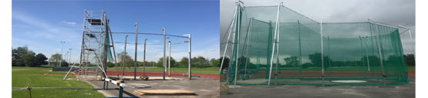



Unit 1, Grosvenor Industrial Estate, Grosvenor St, Ashton-Under-Lyne, Lancashire, OL7 0RE
Telephone: 0161 214 87220161 339 8722 Fax: 0161 339 6108
Follow Us


Call
Send SMS
Add to Skype
You'll need Skype CreditFree via Skype

