100 years ago over 250 members of Birchfield Harriers joined up to go to war.
Many lives were lost or ruined by World War One, including many from Birchfield.
This event is in their memory.
Birchfield Harriers with support from Midland Counties AA – present an Open Meeting where track and field events will return to using yards and miles.
There will also be some multi-event options for younger athletes.
Medals and awards in all events. Some special awards in some events. Including;
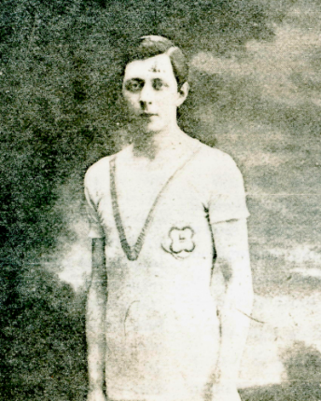
The Charlie Ray 220 yards – Charlie pictured left, was 1910 Midland 220y champion, ran to relight fuses under heavy fire.
The Sid Burrell 880 yards – Sid wore his club vest under his tunic when in the trenches – he should have been running in the 1916 Olympics. Picture below right.
The Alfred Wilcox V.C. 1 mile walk. Wilcox was awarded the VC for bravery retaking trenches single handed.
More details http://archive.birchfieldharriers.com/athletes/archives/world-war-i/
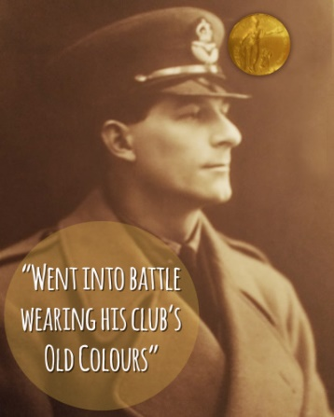
There will also be a “Memorial Mile” where anybody can run, walk, push, wheel or whatever. Period costume is encouraged for this event. A limited number of field events will be measured in feet and inches (but converted to metric for power of ten!) Other activities will be some fun events such as a sack race, egg & spoon race etc. An orienteering maze. Two mile team race. Fancy/period dress competition.
Under 11s – Triathlon (75m, long jump, shot) – entry fee £8
Limited 32 per Age Group
Under 13s – Quadrathlon (75m, long jump, shot, 600m) – entry fee £8
Under 15, Under 17, Seniors – 100 yards, 220 yards, 440 yards, 880 yards, 1 mile
Long Jump, Triple Jump, High Jump, Discus, Javelin, Club Throw
Entry Form
1st Name |  |  |  | Surname
Address

Telephone
 |  |  |  |  | Postcode
Registration Number (EA) |  |  |  | CLUB
Date of Birth  DD/MM/YY | DD | MM | YY | Age Group  e.g. U13G, U17M |  |  |  | PLEASE inc Gender! B/G M/W
Events and Personal Bests (2015 -2016 “metric” performances)
Event 1 | Event 2 | Event 3 | Event 4 * | Disability Classification  (if applicable)
PB | PB | PB | PB
* Please observe UKA rules for maximum number of events for your age group (max 3)
Entry Fees |  | Fee per event |  | Number of events | Total
 |  | £8
Office Use Only |  |  | Please DO NOT send cash in the post  Cheques payable to “Birchfield Harriers”
Cheque | Cash
Send to: Birchfield Retro Open, 75 Beech Tree Road, Walsall Wood, WS9 9LS
Please write e-mail below – timetable will be sent on Aug 29th
Email | @
WEBSITE WWW.BIRCHFIELDHARRIERS.NET

